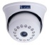
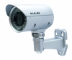
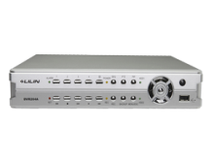
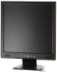
Indoor Camera Outdoor Camera DVR / NVR Monitor

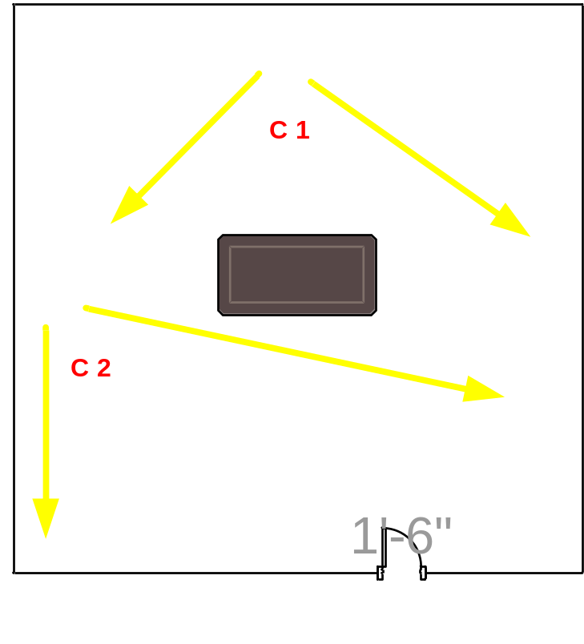

Customer Name | Dilmah - Airport
Drawing Title | CCTV
Issue No | RE/TE
Issue Date | 3/3/2018
Revision No
Revision Date
Created By | Ajith Fernando
Approved By

